HTML Questions

1. What is Language?

Language is a structured system of communication that consists of grammar and vocabulary. It is primary means by which human convey meaning, both in spoken and sign forms, and may also be conveyed through writing.

1. What is markup language?

A markup language is a set of rules that defines how the layout and presentation of text and images should appear in a digital document.

It allows structuring documents, adding formatting, and specifying how different elements should be displayed (or “rendered”) on web pages.

1. Types of languages?
2. Procedural programming language
3. Functional Programming language
4. Object Oriented Programming language
5. Scripting Languages
6. Logic Programming language - Prolog, Absys
7. Markup language
8. What is diff between markup and programming language?

The markup languange is used to present information where as programming languange is used to give instructions to a computer to perform a particular task.

1. What is difference between markup and scripting languange?

Markup Languages are completely different from Scripting languages where markup languages prepare a structure for the data or prepare the look or design of a page.

Scripting language is all about giving the script to perform some certain task. Scripting languages are basically the subcategory of programming languages which is used to give guidancce to another program or we can say to control another program, so it also involves instructions.

1. What is Server?

Server is a hardware device or software that process requests sent over a network and replies to them. A client is the device that submits a request and waits for a response from the server. The computer system that accepts requests for online files and transmits those files to client is referred as a server.

1. What is Domain?

Domain names are a key part of the internet infrastructure. They provide a human readable address for any web server available on the internet.

Each website has a domain name (e.g.,

www.example.com), which is a human-readable address that

maps to an IP address (e.g., 192.0.2.1) used by computers to

locate the website's server on the internet.

1. How does internet works?

The internet is a network of computers that use cables, wires, radio waves and other networking infrastructure to connect and exchange information.

Data is coverted into pulses of electricity or light, called “bits,” and sent at the speed of light through the wires, cables and radio waves.

The more bits that can pass throught at once, the faster the internet works.

1. What does developer do?

Software developers develop the software and are responsible for the activites related to software, which include designing, programming,creating, implementing, testing, deploying and maintaing

Software. Software developers develop system software, programming software, and application software.

A software developer creates computer programs or applications. They use their coding skills to write instructions that tell computers what to do. They develop instructions that tell computers what to do using their coding talents.

“A developer is someone who designs, writes, tests, and maintains code to create software applications, websites, or systems. Developers use programming languages to turn ideas and specifications into functioning software. Their role can vary based on their area of expertise, the specific industry they work in, and the type of software they build.

1. Types of server?
   1. Application server
   2. Catalog server
   3. Communication server
   4. Computing server
   5. Database server
   6. Fax server
   7. File server
   8. Game server
   9. Mail server
   10. Print server
   11. Proxy server
   12. Web server
2. What is HTML?

Hyper Text Markup language(HTML) is the standard markup language used to create web pages. It is a combination of Hypertext and markup language.The Hypertext defines the link between web pages, and Markup defines the text document within tags to structure the web pages.

1. Father of html?

Tim Berners-Lee (born 8 june 1955) also know as TimBL, is an english computer scientist best known as the inventor of the world wide web, the HTML mark up language, the URL system and HTTP.

1. What is diff between 3.0, 4.0, 5.0 in html?

3.0 :

Introduced more advance features for formatting web pages.

Introduced advance layout features but was never fully adopted due its complexity and limited browser support.

4.0:

(Adopted)Standardized the use of css for styling, improved web accessibility, and established the separation of content and presentation.

5.0:

This is the latest major version

It added multimedia support(video, audio), new semantic elements(like <header>, <article>), mobile friendly design, and integrated modern web Api’s for dynamic content.

1. What is tag?

A Tag is a keyword enclosed with “<” and “>” in HTML language.

1. Types of tag?

Paired tags

Un-Paired tags

**Paired tags:** Paired tag is also know as paired element or container tag. The tag having both opening tag and closing tag is know as paired tag.

Ex: <p> content </p>

**Unpaired Tags:** Unpaired tags, also known as self closing tags or void tags. The tags which does no require a separte closing tag because they don’t enclose with any content.

Ex: <br>, <img>, <input>, <hr>

1. What is elements?

An html element is component of an html document that tells a web browser how to structure and interpret a part of the html document.

Html elements are the basic buliding blocks used to create and structure a webpage. An html element typically consists of start tag, content and end tag. Some elements are self closing and don’t require an end tag.

1. Types of elements?

Inline

Inline-block

Block

1. Inline vs Inline-block vs block with examples?

**Inline:** Inline elements sit on the same line with other inline elements and this inline element occupy only the width necessary to display content.

**Inline - Block :** Inline - block element will take up specific width and height. But it will also not start on a new line withn its parent or cause a line break after it.

**Block:** Block elements always start on a new line before and after the element itself. Where it occupy total width.

1. Explain the structure of element?

An HTML element is the fundamental unit used to define the content and structure of a webpage. The structure of an HTML element typically consists of three parts:

1. Opening tag
2. Content
3. Closing tag

Basic Structure:

<element_name>Content goes here</element_name>

Opening Tag:

* The opening tag indicates the beginning of an element. It is enclosed in angle brackets (< >).
* The tag may also contain attributes that provide additional information about the element.

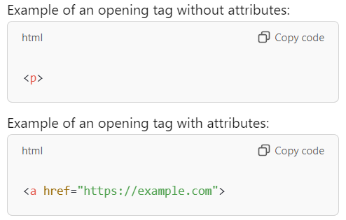

Content:

The content is the text or other HTML elements that appear between the opening and closing tags.

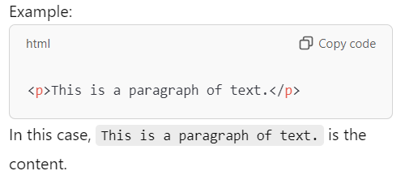

Closing tag:

The closing tag marks the end of the element. It is similar to the opening tag, but it includes a forward slash (/) before the element name.

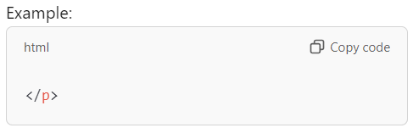

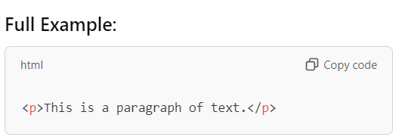

1. What is Doctype?

The Doctype declaration is an instruction to the web browser about what version of html the page is written in.

1. What if I remove Doctype?

It will result in compatibility issues with different browsers and outdated versions of the same browser.

If you remove the DOCTYPE declaration in an HTML document, the browser will switch the page to Quirks Mode instead of Standards Mode. This can lead to inconsistent behavior, causing the webpage to display differently across various browsers or compared to modern web standards.

1. What is quicrks mode in HTML?

Quirks mode is an approach used by web browsers to maintain backward compatibility with web pages designed for old web browsers, instead of strictly complying with web standards in standards mode.

1. Element vs tag vs container?

Element: The full structure that includes the opening tag, content, and closing tag. It represents a specific part of the webpage (e.g., a paragraph, a header, an image).

Example: <p>This is a paragraph.</p>

Tag: The actual part of the element that defines the start or end. Tags wrap the content and other elements.

Example: <p> (opening tag) and </p> (closing tag)

Container: An element used to group other elements together, primarily for layout or structural purposes.

Example: <div> or <section>, which are used to organize content on the page.

1. What is anchor tag and explain its attributes?

The anchor tag, represented in HTML as <a> is used to create hyperlinks on web pages. It allows users to navigate between different web pages, sections within the same page, or external resources such as documents or websites.

Attributes are:

1. Href : The href attribute specifies the URL the link points to (https://www.example.com in this case). Clicking on the link will take the user to this URL.
2. Target: The target attribute specifies how the link should open. In this case value, “_blank ” means the link should open in a new tab or Window.
3. Explain _parent and _top in anchor tag?

_parent: It opens the linked document in the parent frameset.

_top: It opens the link document in the named frame.

1. What is diff b/w HTML and XHTML?

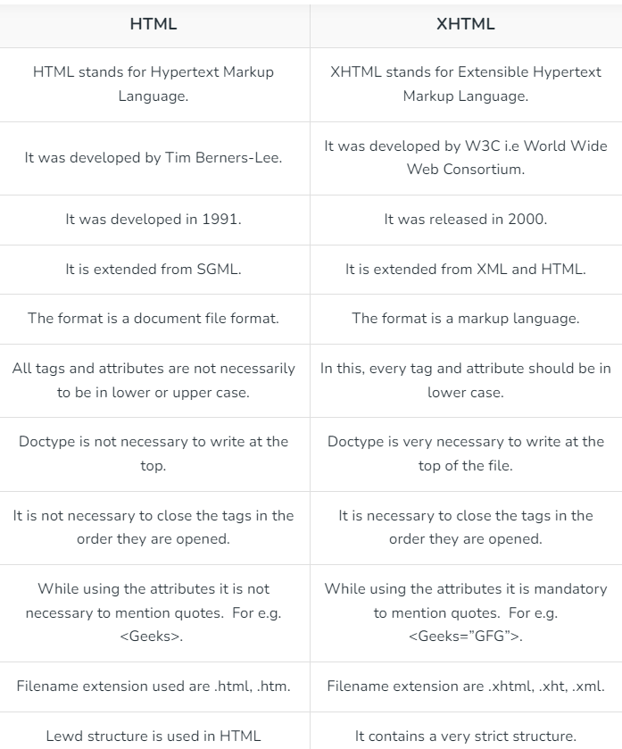

1. What is diff b/w .htm and .html?

The Main difference between Html and htm is one letter only(L). Earlier operating systems were not so powerful and capable of taking a four-letter word as an extension, So htm found its existence.

1. Importance of lang= “en” in html?

The languange attribute in html tag specifies the language of the element’s content. For example “en” for English, “es” for Spanish and so on.

1. What are deprecated tags and alternatives?

Deprecated tags & attributes are those tags that are no longer valid to use and have been replaced by more modern, standard-compliant elements or CSS techniques.

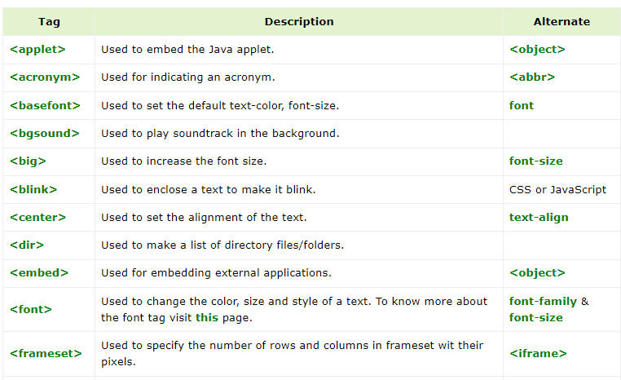

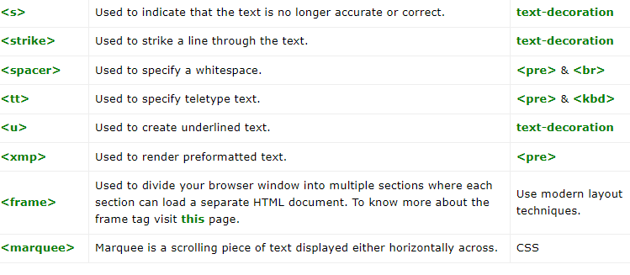

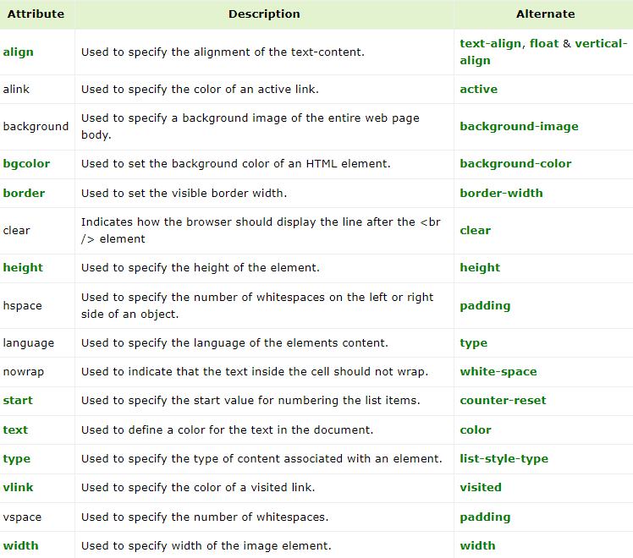

1. Types of Markup language?

Markup languages are computer languages that are used to structure, format, or define relationships between different parts of text documents with the help of symbols or tags inserted in the document.

Types:

1. HTML
2. XML
3. XHTML
4. SGML

HTML: Hypertext Markup Language ([HTML](https://www.geeksforgeeks.org/html-introduction/)) is a markup language used to create and link webpages. It defines the basic structure of a web page and contains meta-data about the page and a series of elements to be displayed on the web page.

XML: **Extensible Markup Language (**[XML](https://www.geeksforgeeks.org/xml-basics/)**)** is a markup language used for storing structured data. It uses custom tags to define the elements which support a wide range of elements. It was developed because HTML was unable to define new elements hence XML was introduced which was extensible to define custom elements.

XHTML: **Extensible Hypertext Markup Language (XHTML)** is a markup language that is used to create HTML documents that support custom tags to define new elements. It is more strict than HTML in terms of error handling i.e browser doesn’t display web pages in case of errors in the markup document. It creates an XML version of the HTML document which must be marked up correctly.

SGML: Standard Generalized Markup Language ([SGML](https://www.geeksforgeeks.org/sgml-full-form/" \t "https://www.geeksforgeeks.org/explain-different-markup-languages-other-than-html/_blank)) is a markup language that provides a standard for defining markup languages. It is used for marking up files such that they are no longer dependent on any other application. It uses .sgml extension for saving SGML files. It manipulates massive files which require frequent revisions and is a part of complicated systems.

1. What if I keep any tag in head tag, what is the behaviour?

If we place any tags within the head tag that don’t belong there, the browser behaviour and the webpage’s functionality might be be affected.

1. Explain p, h1-h6, pre?

The <p> tag in HTML is used to define a paragraph of text. It is one of the most commonly used tags for structuring and organizing textual content on a web page.

Heading Tags(h1-h6):

Heading tags in HTML are used to define the hierarchy and structure of content on a web page.

**h1:**Represents the main heading or title of a page.

Typically used for the most important content on the page.

Should be used only once per page to denote the primary

heading.

**h2:**Represents a secondary heading.Used for subheadings

or sections that are less prominent than h1 but still

important.

**h3**:Represents a tertiary heading.

Used for subsections within h2 sections or to further divide

content.

**h4**:Represents a heading of lower importance than h3.

Used for sub-subsections or minor divisions within h3

sections.

**h5**:Represents a heading of lower importance than h4.

Used for less significant headings within the content

hierarchy.

**h6**:Represents the least important heading.

Used for minor headings or subheadings within a specific

context.

1. Explain diff b/w src and href?

Href attribute:

href attribute is primarily associated with hyperlinks and It is used to define the url or path to the linked resource.

It specifies the destination of the hyperlink, whether it’s a web page, an external resource, or an intenal anchor within the same page.

SYNTAX:

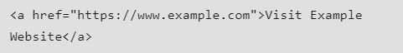

Src attribute:

The src attribute is commonly used with elements like <img>, <script>, <iframe> and others. It specifies the source url or path for embedding external content.

It defines the source of the content to be embedded, whether it’s an image, a script, an audio or video file etc.

SYNTAX:



1. What is picture tag?

The <picture> tag provides flexibility for defining image resources, ideal for responsive designs and art. It includes multiple <source> tags for different media queries and an <img> tag as a fallback to ensure compatibility with browsers that don’t support the <picture> element or if no <source> tags match.

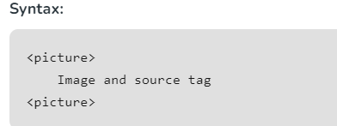

1. Explain Table Tag and their attributes?

Html tables are used to display data in a structured format with rows and columns. They are defined using the <table>tag.

**Basic Structure**

A basic HTML table consists of:

• <**table**>: The container for the table.

• <**tr**> (table row): Defines a row in the table.

• <**th**> (table header): Defines a header cell in the table.

• <**td**> (table data): Defines a standard cell in the table.

Ex:

<table>

<tr>

<th>Header1</th>

<th>Header2</th>

</tr>

<tr>

<td>Data 1</td>

<td>Data 2 </td>

</tr>

</table>

**Attributes:**

**colspan**: Specifies the number of columns a cell should span (merge or expand).

**rowspan**: Specifies the number of rows a cell should span (merge or expand).

**border**

Defines the border width of the table and its cells.

<table border="1">

**cellpadding**

Defines the space between the cell content and its border.

<table cellpadding="10">

**cellspacing**

Defines the space between cells.

<table cellspacing="10">**Width and height**

Defines the width and height of the table.

<table width="500" height="300">

**bgcolor**

Defines the background color of the table, rows, or cells.

<tr bgcolor="yellow">

1. Explain thead, tbody, tfoot in table tag ?

<thead>: It groups the header content in a table.

<tbody>: It groups the body content in a table.

<tfoot>: It groups the footer in a table.

1. How formatting tags play major role in screen readers?

Formatting tags play a crucial role in how screen readers interpret and vocalize content on a webpage. Screen readers rely on HTML tags to understand the structure and context of the page, which helps visually impaired users navigate effectively. Here’s how different formatting tags contribute:

**Headings (<h1> - <h6>)**: Headings create a clear hierarchy on the page. Screen readers can navigate through headings, enabling users to jump directly to sections. Without proper heading tags, screen reader users may struggle to understand the content flow.

Landmarks (<nav>, <header>, <main>, <footer>): Landmark tags help screen readers identify key page areas, allowing users to skip directly to sections like navigation, main content, or the footer.

Lists (<ul>, <ol>, <li>): Lists are announced as such by screen readers, allowing users to anticipate multiple items in a list format. Properly marked lists help users understand itemized information or steps.

Links (<a>): Descriptive link text is essential. Screen readers often list all links on a page, so using meaningful link text (instead of "click here") provides context. ARIA attributes like aria-label can add more detail for screen readers without impacting the visual text.

Tables (<table>, <th>, <tr>, <td>): Screen readers rely on table tags to read tabular data accurately. Marking headers with <th> and rows/columns properly helps screen readers convey the data's structure, allowing users to navigate cells correctly.

Emphasis and Strong Tags (<em>, <strong>): Emphasis and strong tags signal importance and emphasis, affecting how screen readers vocalize the text (with slight pauses or tonal changes), adding depth to the interpretation.

Alternative Text (alt in <img>): Screen readers rely on alt text to describe images, charts, or icons to users who cannot see them, making visual information accessible.

ARIA roles and labels: These attributes provide additional context or identify complex interactive elements (like sliders, modals, or navigation menus) that native HTML tags alone cannot describe. ARIA helps ensure screen readers interpret interactive elements correctly.

By using these tags and attributes correctly, web developers create a more accessible experience, enabling screen readers to relay content more naturally and interactively.

1. What is map tag?

The <map> tag is used to define an image map. An image map is an image with clickable areas. The required name attribute of the <map> element is associated with the <img>'s usemap attribute and creates a relationship between the image and the map.

1. What is q and Blockquote tag?

<q> tag:

The **<q> tag** is used to provide small quotations to the HTML content, in this case, the browser simply puts a quotation around the content inside the tag. This tag is also known as inline quotation which means it will not break to the next line.

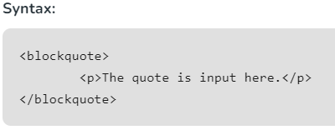

Blockquote tag:

The **<blockquote> tag** in HTML is used to display the long quotations (a section that is quoted from another source). It changes the alignment to make it unique from others. It contains both opening and closing tags.

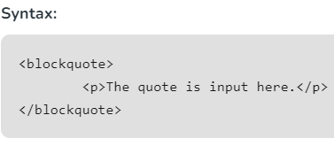

1. What is kbd tag?

The <kbd> tag is used to define keyboard input. The content inside is displayed in the browser's default monospace font.

1. Explain diff b/w description list and details and summary tag?

The difference between a **description list** (<dl>, <dt>, <dd>) and the **details and summary** tags (<details>, <summary>) in HTML lies in their usage and purpose. Here's a breakdown:

### 1. ****Description List**** (<dl>, <dt>, <dd>)

A **description list** is used to represent a list of terms and their corresponding descriptions. It is a way to organize information that pairs a term with its definition or description.

* <dl>: Wraps the entire description list.
* <dt>: Stands for "description term," and it defines the term that is being described.
* <dd>: Stands for "description definition," and it defines the description or definition of the term.

Ex:

<dl>

<dt>HTML</dt>

<dd>A markup language for creating web pages.</dd>

<dt>CSS</dt>

<dd>A style sheet language for designing web pages.</dd>

</dl>

In this example, **HTML** and **CSS** are terms (<dt>) and their descriptions (<dd>) explain what they are.

### 2. ****Details and Summary**** (<details>, <summary>)

The **details and summary** tags are used to create an expandable/collapsible section on the webpage. The <details> tag is used to encapsulate the content that can be toggled (shown or hidden), and the <summary> tag provides a clickable heading for the expandable content.

* <details>: Wraps the entire collapsible section.
* <summary>: Specifies the title or clickable text that is visible to the user, which controls the expansion or collapse of the section.

Ex:

<details>

<summary>What is HTML?</summary>

<p>HTML is a markup language for creating web pages.</p>

</details>

In this example, clicking on the **What is HTML?** heading will expand or collapse the content inside the <details> tag.

### Key Differences:

* **Purpose**:
  + **Description List**: Used to define terms and provide corresponding definitions or descriptions.
  + **Details/Summary**: Used to create collapsible sections of content for easier user interaction.
* **Interaction**:
  + **Description List**: Static; no interaction is involved. It's purely for presenting information.
  + **Details/Summary**: Interactive; users can expand or collapse content by clicking on the summary.
* **HTML Semantics**:
  + **Description List**: Represents structured data (terms and definitions) with a semantic relationship.
  + **Details/Summary**: Represents an interactive disclosure widget that allows users to hide or show content dynamically.

Both serve different purposes depending on the structure and interactivity needed for the content.

1. Explain lists tag?

An**HTML list** is a record of related information used to display the data or any information on web pages in the **ordered**or **unordered form**.

Types of lists tags:

1) Unordered list

2) Ordered list

3) Description list

**Unordered List <ul>**:

• Creates a list of items without any specific order.

• Attributes:

• **type**: Specifies the bullet style. Values can be "**disc**" (default),

"**circle**", or "**square**".

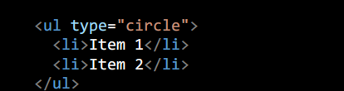

**Ordered List <ol>**:

• Used to create a list of items In specific order

• Attributes:

• **type**: Specifies the numbering style. Values can be "**1**" (default,

decimal), "**A**" (uppercase letters), "**a**" (lowercase letters), "**I**"

(uppercase Roman numerals), "**i**" (lowercase Roman numerals).

• **start**: Specifies the starting value of the first item.

• **reversed**: Reverses the numbering order

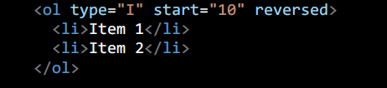

**Description List <dl>**:

• Creates a list of term-description pairs.•

Attributes:

• None

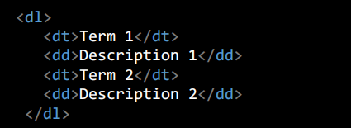

1. Explain iframe tag?

Iframe element is used to embed another html document within the current html documnet. It allows you to display content from another source, such as a different website or a different page

1. What is embedded links?

An embedded link is a link that does not show the exact URL to the web page. What you 'embed' or put inside, is the URL.

1. Why iframe does not support direct links?

The <iframe> element can support direct links, but websites may block embedding due to security policies like X-Frame-Options and Content Security Policies (CSP).

1. Different b/w Client and Server?

* A client is a piece of hardware or software that requests resources or services from a server.
* A server is any piece of hardware or software that provides resources or services to users
* Clients and servers communicate with one another through a network to exchange data and perform various tasks.

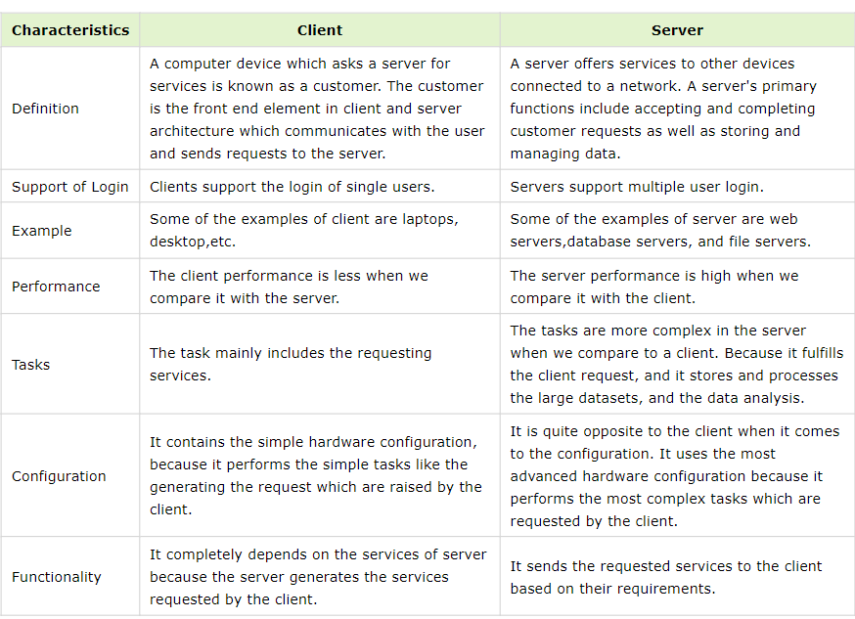

1. Explain diff b/w GET and POST?

**GET:** The HTTP GET method requests data from a server without altering its state. It appends parameters to the URL, making it suitable for retrieving non-sensitive data. Commonly used for viewing content, GET is ideal for requests that don’t involve data modification.

**POST:** The HTTP POST method sends data from the client to the server to create or update resources, storing data in the request body. It’s suitable for secure data transfer, like images or documents, with security relying on encryption (HTTPS), authentication, and validation.

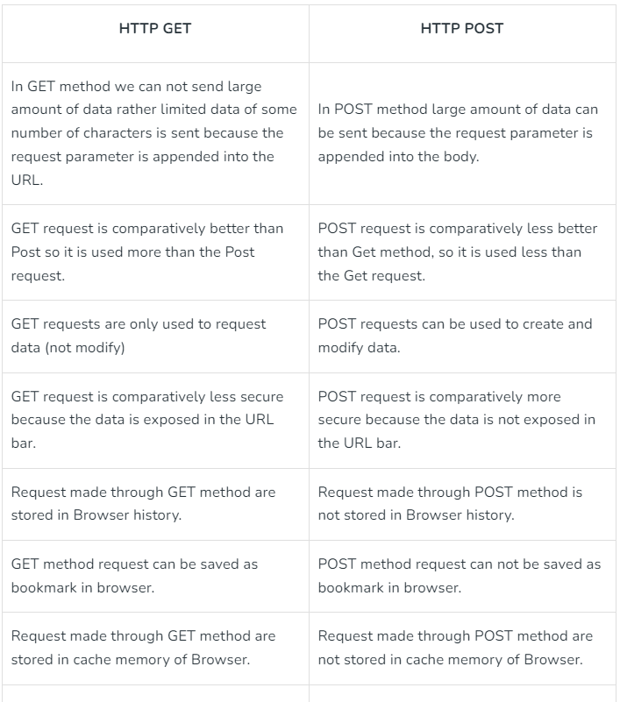

1. What is protocol ?

A protocol is a set of rules that determines how data is sent and received over a network. The protocol is just like a language that computers use to talk to each other, ensuring they understand and can respond to each other’s messages correctly. Protocols help make sure that data moves smoothly and securely between devices on a network.

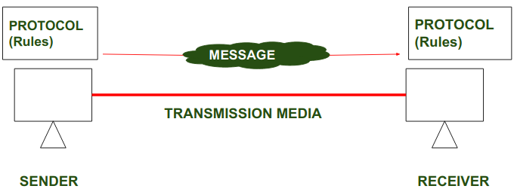

1. What is diff b/w HTTP vs HTTPS?

HTTP: HTTP stands for HyperText Transfer Protocol. It is invented by Tim Berner. HyperText is the type of text that is specially coded with the help of some standard coding language called [HyperText Markup Language (HTML)](https://www.geeksforgeeks.org/html-introduction/). HTTP provides a standard between a web browser and a web server to establish communication. It is a set of rules for transferring data from one computer to another. Data such as text, images, and other multimedia files are shared on the World Wide Web. Whenever a web user opens their web browser, the user indirectly uses HTTP. It is an application protocol that is used for distributed, collaborative, hypermedia information systems.

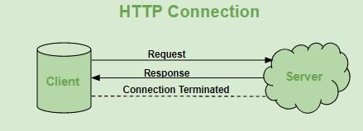

HTTPS: [HTTPS](https://www.geeksforgeeks.org/https-full-form/) stands for Hyper Text Transfer Protocol Secure. HTTP Secure (HTTPS), could be a combination of the Hypertext Transfer Protocol with the SSL/TLS convention to supply encrypted communication and secure distinguishing proof of an arranged web server. HTTPS is more secure than HTTP because HTTPS is certified by the [SSL(Secure Socket Layer)](https://www.geeksforgeeks.org/secure-socket-layer-ssl/). Whatever website you are visiting on the internet, if its URL is HTTP, then that website is not secure.

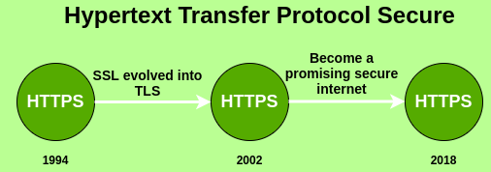

Difference:

Hypertext Transfer Protocol (HTTP) is a protocol using which hypertext is transferred over the Web. Due to its simplicity, HTTP has been the most widely used protocol for data transfer over the Web but the data (i.e.hypertext) exchanged using HTTP isn’t as secure as we would like it to be. [Cryptographic protocols](https://www.geeksforgeeks.org/cryptography-and-its-types/" \t "https://www.geeksforgeeks.org/difference-between-http-and-https/_blank) such as SSL and/or TLS turn HTTP into HTTPS i.e. **HTTPS = HTTP + Cryptographic Protocols**.

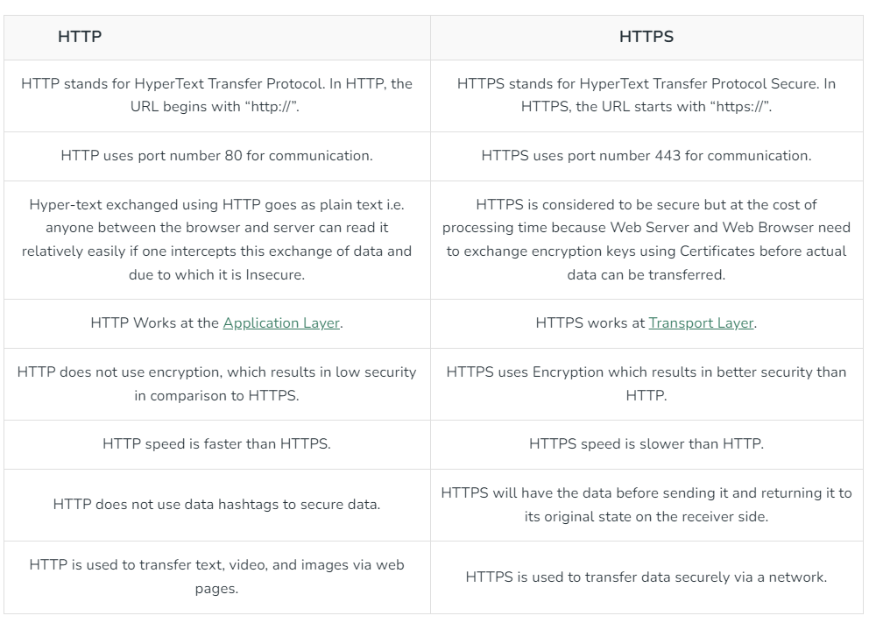

Htttp 80

Htttps 443

1. Explain URL?

Uniform Resource locator is unique identifier that is contained by all resources available on the internet. It can help to locate a particular resource due to its uniqueness. It is also know as the web address.

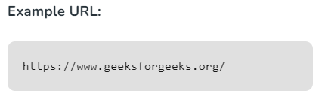

Structure of Url:

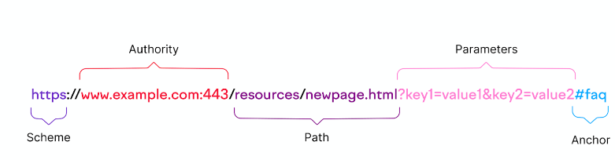

A url starts with a protocol followed by the name of the resource that has to be accessed. URL uses the protocols as the primary access medium to access the domain or subdomain specified after that wherever the resource is located.

A.Scheme:

The Scheme is the first part of the url. It indcates the protocol for accessing the resource.

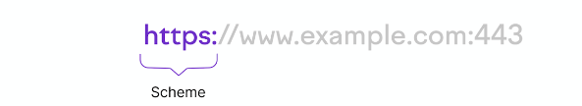

A Protocol is a set of rules for how a connection between browser and web server should be established.

Common schemes are:

1. HTTP
2. HTTPS

HTTP: Hypertext transfer protocol is a main way that web browsers and servers communicate to share information on internet

(or)

HTTP is a standard protocol for establishing the connection between broswer and web sever

* When you enter a URL with the “http” prefix, your browser sends a request to the server to retrieve the resource specified in the URL.
* The server then responds by sending back the requested resource if it’s available.
* But this connection isn’t secure. Which means anyone can intercept and read the data.

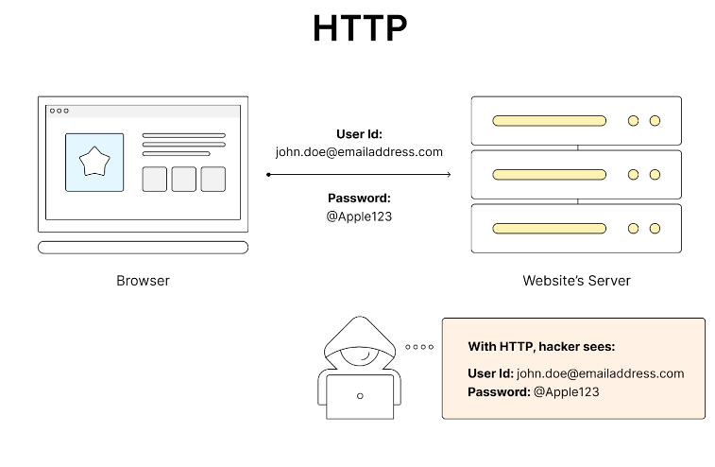

HTTPS: Hypertext Transfer Protocol Secure is a protocol that is used to communicate between the user browser and the website. It also helps in the transfer of data. It is the secure variant of HTTP. To make the data transfer more secure, it is encrypted. Encryption is required to ensure security while transmitting sensitive information like passwords, contact information, etc.

* This hypertext transfer protocol Secure is also same HTTP but in the HTTPS It will add an encrption layer to our web session. Which keeps our data secure.
* This means that any information transferred between your browser and the server is encrypted and much harder for outsiders to intercept.

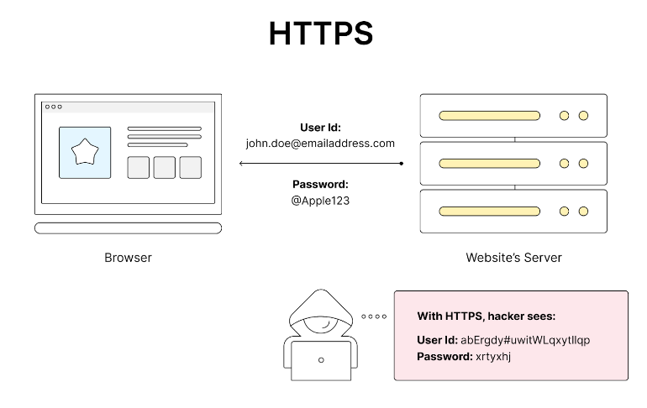

1. Authority:

The authority is the second part of a URL that comes after the “://” character pattern.

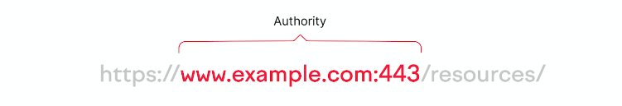

It tells your browser where to find the site and who it belongs to.

This part of the URL consists of four main components:

1. Subdomain
2. Domain
3. Top level domain
4. Port

Subdomain:

A subdomain is a string of letters or a complete word that appears before a URL’s first dot.

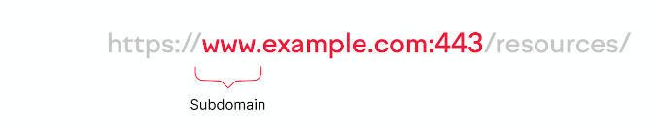

The Most popular Subdomain is www. It stands for World wide web, communicating that the url is a web address.

Domain:

A Domain is the name of a website. Like eBay, Flipkart or Amazon.

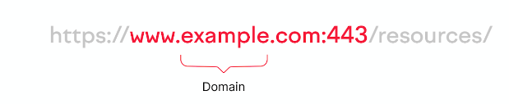

It’s an easy-to-remember part of the URL. Each domain is Unique. So when ever you type it in, You Reference a specific Website you intend to visit.

Top Level Domain:

The Top-Level domain(TLD) also called domain extension is the part that comes after the name of your website. Like “.com”

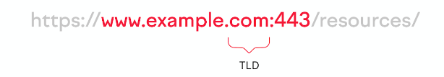

We come across many TLD’s on the internet. The Five most common ones are:

* .com: Commercial websites
* .org: Nonprofit Organizations
* .net: Software and hosting companies providing network services.
* .edu: Educational institutions (universitites, colleges, schools,etc)
* .gov: Government Agencies and Departments

Additionally, there are country-code top-level domains (ccTLDs). ccTLDs are two-letter domain extensions that indicate a website’s association with a specific country or territory.

Examples include:

* .uk for United Kingdom
* .de for Germany
* .cn for China
* .ca for Canada
* .in for India
* .es for Spain
* .au for Australia
* .nz for New Zealand

Websites use ccTLDs when their target audience is predominantly based in a specific country.

By using ccTLD, a website signals its connection to that location. Which can help to establish trust and credibility with users in that region.

Port:

A port is the numerical identifier that specifies a particular gateway for directing traffic to your web server.

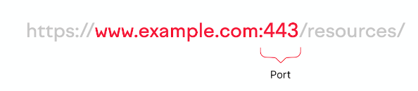

It’s like a door people pass through to visit your site.

Most of the time, you don't see port numbers in URLs because they're using standard ports. Which browsers assume by default (e.g., port 80 for HTTP and port 443 for HTTPS).

Path:

The next part of the url is the path. And it indicates the specific directions to the page being requested on a domain.

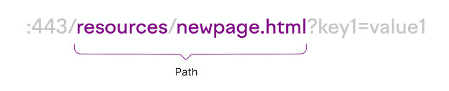

It’s like the exact route you take to a room in a large building (the domain).

Generally, the path is made up of two parts:

1. Subfolder
2. Slug

Subfolder:

A subfloder is a folder or directory located in the main directory that houses the page a user has requested.

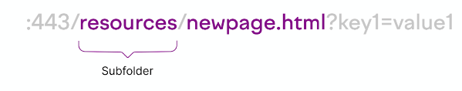

Subfolders allow websites to organize related pages together within the domain's overall directory structure.

Like this:

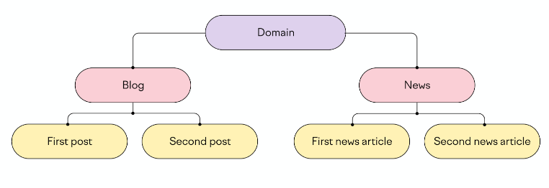

Here, "blog" and "news" are subfolders within the main domain that both organize related content.

URLs for these four pages would look something like this:

* https://www.example.com/blog/first-post
* https://www.example.com/blog/second-post
* https://www.example.com/news/first-news-article
* https://www.example.com/news/second-news-article

Slug:

A slug is the last segment of the path that identifies a particular page. Often, in a human-readable format.

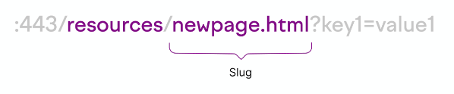

It helps users understand where exactly they are on the website.

Parameters:

Parameters (or query strings) are an optional part of a URL that comes after a question mark (?).

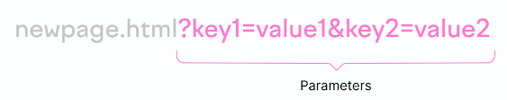

* They modify the contents of a page based on the key and value specified.
* The key is like a label that says what to change. The value specifies the exact modification criteria.

Let’s use the example URL below to understand this better.

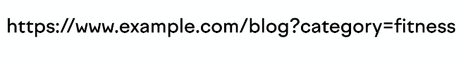

* In this example, “category” is the key and “fitness” is the value. This parameter will apply a filter to a webpage to display only fitness-related blog articles.
* You can add multiple parameters to a URL by separating them with an ampersand (&).

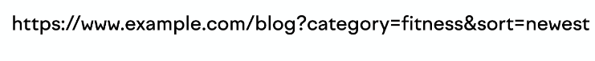

* Now, there are two parameters: “category” with the value “fitness” and “sort” with the value “newest.”
* This applies a filter to a webpage to show blog posts about fitness. And displays them from newest to oldest.

Anchor:

An anchor (also called a fragment identifier) is the optional last part of the URL that takes users to a specific section within a webpage.

It comes after the number (#) symbol.

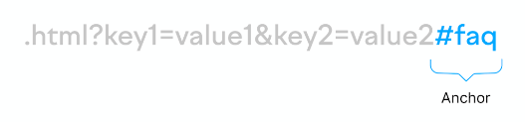

* In the example above, the browser will directly scroll to the FAQ section of the web page rather than opening the web page at the top.
* But anchors aren’t just limited to text content.
* For a video or audio file, the browser will jump directly to the time specified in the anchor.

1. Explain action, method attribute in form tags?

Action attribute is used to specify where the form data is to be sent to the server after the submission of the form. When a user submits a form, the browser sends the data to specified URL, allowing the server-side scripts to handle the information and generate a response.

Method Attribute is used to specify the HTTP method used to send data while submitting the form. There are two kinds of HTTP methods, which are GET and POST. The method attribute can be used with the <form> element.

1. Explain form tag?

HTML forms are used to collect user input. They contain form elements like text fields, checkboxes, radio buttons, and submit buttons, allowing users to input and submit data to a server for processing.

1. Explain multimedia tags?

Multimedia tags allow web developers to embed media content such as images, audio and videos into their web pages.

The 5 most popular multimedia tags are <audio>, <video>, <source>, <embed>, <track>

<audio> : An inline element is used to embed sound files into a web page.

<video> : Used to embed video files into a web page.

<source> : Used to attach multimedia files like audio, video, and pictures

<embed> : Used for embedding external applications, generally multimedia content like audio or video, into an HTML document.

<track> : Specifies text tracks for media components, specifically for audio and video elements.

1. What are different types of input types in form tag?

Input Types: The <input> element is incredibly versatile and can be used for various input types like text, password, checkbox, radio button, date, email, etc. The type attribute specifies the type of input.

1. Explain Fieldset and legend tag?

The Fieldset tag is used to create group related form controls together within a form. It's typically used to create sections or categories within a form, making it easier for users to understand the relationship between different input fields.

The <legend> element is used to provide a title or caption for the <fieldset>. It typically appears as a heading above or beside the group of form controls enclosed by the <fieldset>.

1. What is the use of label tag?

The label tag is used to give caption to form element in a user interface.

1. Diff b/w label tag and placeholder?

The label tag is used to provide a label for a form control such as input field.

The placeholder is used to display the text/caption inside the input field.

Differences are:

The label is always visible to the user unless it is hiden by css.

The placeholder is only visible when the input field is empty or the input field is defined and disappears when user begins typing.

The label is visible outside the input field(above,below or beside).

The placeholder is visible inside the input field.

Clicking the label will focuses the associated input field.

Placeholder is not clickable, where it’s a purely a hint like what to type inside input field.

1. Explain Pattern Attribute?

The HTML pattern attribute is used with <input> elements to specify a regular expression that the input’s value must match for the form to be submitted. It enforces specific formatting rules, like requiring a certain number of characters or specific character types.

Syntax:

<input type = “text” pattern = “Regular exp”>

1. How to achieve HTML validations?

HTML validation is a check to see if a website's source code complies with certain standards.

There are many ways to achieve html validations:

* Required fields : The required attribute ensures that an input field must be filled out before the form is submitted.

EX:

<form>

<label for="username">Username:</label>

<input type="text" id="username" name="username" required>

<input type="submit" value="Submit">

</form>

The form cannot be submitted unless the username field is filled.

* Pattern matching: The pattern attribute allows you to define a regular expression (regex) that the input value must match.

Ex:

<form>

<label for="phone">Phone Number:</label>

<input type="tel" id="phone" name="phone" pattern="[0-9]{3}-[0- 9]{3}-[0-9]{4}" required>

<input type="submit" value="Submit">

</form>

Here the pattern should be 123-456-7890 to validate user input

* Input type:

Different input types provide specialized validation automatically.

type="email" ensures that the input is a valid email address.

type="url" ensures that the input is a valid URL.

type="number" ensures that the input is a valid number.

type="tel" ensures valid telephone numbers.

Ex:

<form>

<label for="email">Email:</label>

<input type="email" id="email" name="email" required>

<input type="submit" value="Submit">

</form>

Here in this above example it will validate the email correct or not.

* Max and Min Length: The minlength and maxlength attributes enforce restrictions on the length of the text entered.

Ex:

<form>

<label for="password">Password (8-16 characters):</label>

<input type="password" id="password" name="password" minlength="8" maxlength="16" required>

<input type="submit" value="Submit">

</form>

The user must enter min 8 and max 16 characters long to validate.

* Numeric Ranges: The min, max, and step attributes ensure numeric inputs fall within a certain range and step value.

Ex:

<form>

<label for="age">Age (between 18 and 60):</label>

<input type="number" id="age" name="age" min="18" max="60" required>

<input type="submit" value="Submit">

</form>

The age must be between 18 and 60.

* Custom Error Messages(title : attribute): You can provide a custom error message using the title attribute, which will be displayed when the input doesn’t match the required pattern or length.

Ex:

<form>

<label for="zipcode">Zip Code:</label>

<input type="text" id="zipcode" name="zipcode" pattern="[0-9]{5}" title="Please enter a 5-digit zip code." required>

<input type="submit" value="Submit">

</form>

If the user doesn’t enter a 5-digit zip code, the custom message "Please enter a 5-digit zip code" will be displayed.

1. Explain output tag?

The <output> tag is typically used within forms to display results based on user input or calculations. It can be associated with form controls using the for attribute, which links it to specific <input> elements.

The <output> tag supports several attributes:

for: A space-separated list of element IDs that the output is associated with.

name: Used to name the output, allowing it to be referenced in scripts or form submissions.

id: A unique identifier for the output element, useful for targeting with scripts and styling.

1. Explain svg tag?

SVG stands for Scalable Vector Graphics. It defines vector-based graphics in XML format. SVG graphics do not lose any quality when zoomed or resized, and every element and attribute in SVG files can be animated.

1. Explain SEO

SEO stands for Search Engine Optimization. It is process of improving the website’s visibility and ranking in search engine page results(SEPR’s) for relavant keywords.When people search for terms related to your website's content or offerings, good SEO helps your site appear higher up in the organic search results (the unpaid listings, not ads). This can significantly increase organic traffic to your website.

Several key practices contribute to good SEO:

♦ Keyword Research: Identify the keywords and phrases that potential

customers are likely to use when searching for products or services

like yours. Tools like Google Keyword Planner can help with this.

♦ Content Creation: Create high-quality, informative, and engaging

content that addresses your target audience's needs and incorporates

relevant keywords naturally.

♦ On-Page Optimization: Optimize individual website pages for

relevant keywords by including them in titles, headings, meta

descriptions, and image alt tags.

♦ Technical SEO: Ensure your website is mobile-friendly, has a clean

and efficient code structure, and loads quickly.

♦ Link Building: Earn backlinks (links from other websites to yours)

from high-quality, relevant websites. This signals to search engines

that your website is trustworthy and credible.

1. Explain SDLC?

SDLC is a structured process to design or build a software.

SDLC (Software Development Life Cycle) is a process followed for software development, consisting of a detailed plan describing how to develop, maintain, replace, and alter or enhance specific software.

There are 7 phases in SDLC:

1.Planning:

The goal of this phase is to outline the project and its feasibility. It involves defining the project scope, objective, risks and cost estimation.

2.Requirement Analysis:

This phase focuses on gathering and analyzing all the requirements for the software. It includes understanding what the users need, the functional and non-functional requirements, and documenting them.

3.Design:

In this phase, the system architecture is designed based on the requirements gathered in the previous phase. The Design phase includes both high-level design(HLD) and low-level design(LLD).

Prototype development for user feedback.

4.Development:

This phase is where actual coding takes place based on the system design.

5.Testing:

The testing phase ensures that the software is free of bugs and meets the functional and non-functional requirements. It can involve several types of testing - unit testing, integration testing, system testing and acceptance testing.

6.Deployment:

In this phase, the software is deployed into the production environment where users can start using it.

7.Maintenance:

After deployment, the software enters the maintenance phase. This phase ensures that the system operates smoothly and continues to meet user needs.

1. Explain Meta tag?

The <meta> tag in HTML is used to provide metadata about the HTML document. Metadata is not displayed on the page but is machine parsable. Meta elements are typically used to specify page description, keywords, author of the document, last modified, and other metadata. The metadata can be used by browsers (how to display content or reload page), search engines (keywords), or other web services.

Here are some common attributes used with the <meta> tag:

charset: Specifies the character encoding for the HTML document.

name: Specifies a name for the metadata.

http-equiv: Provides an HTTP header for the information/value of the content attribute.

content: Specifies the value for the metadata.

property: Specifies a property for the metadata.

To refresh a webpage automatically, you can use the <meta> tag with the http equiv attribute set to "refresh" and the content attribute specifying the number of seconds after which the page should be refreshed. This is useful for pages that need to update content in real-time or for demonstration purposes.

<meta http-equiv="refresh" content="5">

Example :

<!DOCTYPE html>

<html lang="en">

<head>

<meta charset="UTF-8">

<meta name="viewport" content="width=device-width, initial-scale=1.0">

<meta name="description" content="This is a description of the

webpage.">

<meta name="keywords" content="HTML, CSS, JavaScript">

<meta name="author" content="John Doe">

<meta http-equiv="X-UA-Compatible" content="IE=edge">

<meta name="theme-color" content="#000000">

<title>Document Title</title>

</head>

<body>

<h1>Welcome to My Website</h1>

<p>This is a sample paragraph.</p>

</body>

</html>

1. Diff b\w semantic Elements and non-semantic Elements?

Semantic elements are tags that convey meaning about the content to the browser and developer. By using semantic elements appropriately, web developers can create documents that are more accessible, search engine-friendly, and maintainable.

list of semantic HTML tags:

<header>, <nav>, <main>, <article>, <section>, <aside>, <footer>, <figure>, <figcaption>, <time>, <address>, <blockquote>, <cite>, <abbr>, <mark>, <audio>, <video>

Non-semantic elements in HTML are HTML tags that do not inherently convey any specific meaning about the content they contain.

list of non-semantic HTML tags:

<div>, <span>, <table>, <tr>, <td>, <th>, <ul>, <ol>, <li>, <dl>, <dt>, <dd>, <form>, <input>, <button>, <textarea>, <select>, <option>, <label>, <iframe>, <iframe>, <script>, <style>, <link>.

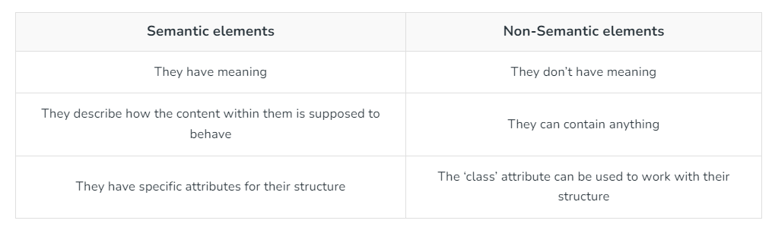

1. Character Entities and Improvements in HTML?

Character Entities:

Character entities in HTML are used to display reserved or special characters that are either difficult to type on a keyboard or might conflict with HTML syntax. They are helpful for including characters that have special meanings in HTML (such as <, >, and &), as well as symbols, accented letters, and non-English characters.

Why Use Character Entities?

* Reserved Characters: Some characters, like <, >, and &, are used to define HTML tags. If these are included directly in HTML, they would be interpreted as part of the code rather than content. For instance, to display an actual < symbol, you use &lt; instead.
* Non-ASCII Characters: Characters not found on a standard keyboard, like accented letters or copyright symbols, can be represented using character entities.
* Uniform Representation: They help display content uniformly across different devices and browsers, particularly for non-standard symbols.

Common Character Entities:

* < → &lt; (Less than)
* > → &gt; (Greater than)
* & → &amp; (Ampersand)
* " → &quot; (Quotation mark)
* ' → &apos; (Apostrophe)
* © → &copy; (Copyright symbol)
* ® → &reg; (Registered trademark)
* € → &euro; (Euro sign)

HTML also supports numeric references for characters:

* Decimal: &#169; (for ©)
* Hexadecimal: &#x00A9; (for ©)

Improvements in HTML (with HTML5):

HTML5 brought several improvements, especially in handling character entities and overall performance:

1. Simplified Doctype Declaration:

Previous versions required verbose and confusing DOCTYPE declarations. HTML5 simplified this with a single line:

<!DOCTYPE html>

2. Global Language Support:

HTML5 added better support for different languages and character encodings:

UTF-8, which covers almost every character in use across languages, is the default encoding in HTML5. This makes it easier to represent a wide variety of symbols and characters without needing specialized entities.

3. New Semantic Elements:

HTML5 introduced more semantic elements (<article>, <section>, <header>, <footer>, <aside>), which not only help in structuring the content better but also improve accessibility and SEO, as mentioned earlier.

4. Multimedia Support (Audio & Video):

Before HTML5, embedding audio and video required external plugins like Flash. HTML5 introduced the <audio> and <video> tags, allowing multimedia content to be embedded directly without external dependencies.

5. Improved Form Controls:

HTML5 added new form input types, such as email, date, color, and range, simplifying user input validation and making forms more user-friendly.

6. Canvas and SVG for Graphics:

HTML5 introduced the <canvas> element and SVG support for creating graphics and animations directly in HTML, enabling developers to build interactive and rich graphical interfaces without external plugins.

7. Local Storage and Web Storage:

HTML5 introduced APIs like localStorage and sessionStorage, enabling developers to store data on the user's browser with no expiration or only for the duration of the session.

8. Support for Responsive Web Design:

HTML5 made it easier to implement responsive web design, primarily through the <meta> viewport tag and improved CSS media queries.

1. The role of Semantic elements?

Semantic elements in HTML play a crucial role in improving both the accessibility and structure of web content. They are HTML elements that carry meaning related to their content, allowing both browsers and developers to understand the purpose of the content they enclose.

1. Explain Figure and FigCaption?

<figure> Element

The <figure> element is used to group media content (like images, diagrams, charts, etc.) along with an optional caption. The content inside the <figure> tag is considered self-contained, meaning that it can be moved or repositioned within the document without affecting the main flow of the content.

<figcaption> Element

The <figcaption> element is used to provide a caption or description for the content inside a <figure>. The <figcaption> tag must be the first or last child of the <figure> element, and it describes the figure's content for users, making it more accessible and meaningful.

1. Explain Marquee tag?

The <marquee> tag in HTML creates a scrolling text or image effect within a webpage. It allows content to move horizontally or vertically across the screen, providing a simple way to add dynamic movement to elements. Although this tag is deprecated in HTML5, it is still useful to understand its functionality for legacy projects.

1. Poster attribute in video tag?

The HTML <video> poster Attribute is used to display the image while video downloading or when user click the play button. If this image not set then it will take the first frame of video as a poster image

1. Explain link tag?

The HTML <link> tag defines the relationship between the current document and an external resource, often for stylesheets or favicons. It’s an empty element with attributes like href and rel.

Syntax:

<link rel="stylesheet" href="styles.css">

1. What is rel attribute?

The <link> rel attribute is an essential part of HTML that specifies the relationship between the current document and a linked document or resource. It is used in conjunction with the href attribute to define how the two documents relate to each other.

1. Anchor tag href - tel, mailto, sms

The href attribute in the anchor tag specifies the destination of the hyperlink.

Tel: It is used to create a clickable phone number.

Mailto: It is used to create a clickable email address.

Sms: It is used to create a alternative redirect link.

1. Anchor tag download attribute?

The HTML download Attribute is used to download the element when the user clicks on the hyperlink. It is used only when the href attribute is set. The downloaded file name will be the value of the attribute. The value of the attribute will be the name of the downloaded file. If the value is removed then the original filename is used.

1. Explain Bookmarking?

Bookmark Link is used for the users to navigate directly to the specific sections within the web application. We can create this bookmark link functionality in HTML using the id attribute with JavaScript and the class attribute with jQuery.